Data Visualisation
Key Insights – Tesla Stock Analysis
Executive Financial Dashboard Summary & Key Takeaways

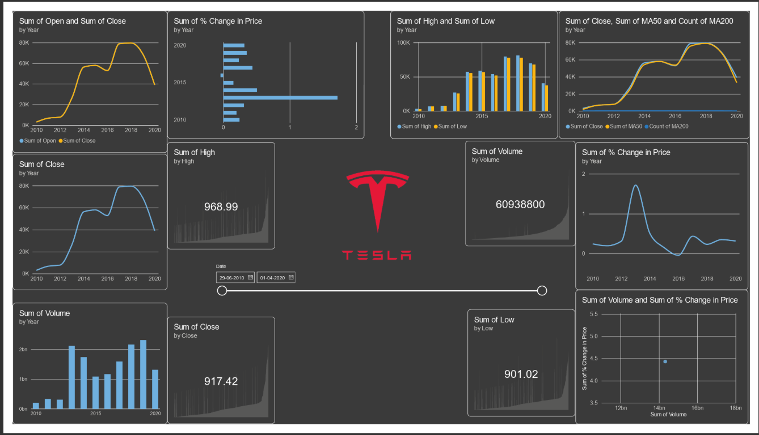

Executive Overview
Based on the historical Tesla stock dataset and interactive Power BI visualizations, this document synthesizes key analytical findings regarding long-term growth, market volatility, trading volume dynamics, and intraday price behavior. These structured insights are designed to support data-driven decision-making and accompany executive dashboard presentations.

Dashboard Key Insights Summary Matrix
Category | Metric / Feature | Recommended Visual | Core Analytical Finding
Trend Analysis | Long-Term Closing Price | Line Chart | Strong upward trend overall, accompanied by distinct cyclic fluctuations.
Momentum | 50-Day & 200-Day Moving Avg | Multi-Line Overlay Chart | Price above averages signals upward momentum; crossovers mark key sentiment shifts.
Volatility | Daily Price Change (%) | Bar Chart / Histogram | High frequency of wide daily swings, confirming substantial stock volatility.
Risk & Correction | Peak-to-Trough Drawdowns | Area Chart | Notable periods of sharp decline exist within the context of broader growth.
Volume & Price | Daily Trading Volume vs Price | Scatter Plot | High volume aligns with extreme price shifts, reflecting surging investor participation.
Intraday Trading | High vs. Low Range | Candlestick / Range Chart | Expanding daily High-Low gaps highlight highly volatile trading sessions.
Session Performance | Open vs. Close Delta | Column Chart | Measures net intraday gain or loss across individual trading sessions.

Detailed Analytical Insights

1. Growth & Trend Dynamics
- 📈 Strong Long-Term Growth
Tesla’s closing price demonstrates a significant overall upward trend across the analyzed timeframe. While long-term appreciation is substantial, the trajectory features several pronounced expansion and contraction cycles rather than linear growth.
- 💹 Moving Average Trend Alignment
The 50-day and 200-day moving averages provide crucial context for evaluating macro market direction. When the daily closing price consistently trades above these moving averages, it confirms underlying bullish momentum and strong buying support.
- 📉 Noticeable Price Corrections
Despite the overarching upward trend, the dataset reveals periods of severe price drops and rapid pullbacks. These sharp corrections emphasize that long-term gains are coupled with significant short-to-medium-term drawdown risks.

2. Price Volatility & Intraday Behavior
- 📊 High Price Volatility
The distribution of daily price-change data reveals substantial percentage gains and losses within short windows. This spread underlines Tesla's classification as a high-beta, highly volatile asset.
- 📅 High vs Low Comparison (Intraday Spread)
The spread between daily high and daily low prices provides visibility into session volatility. Wider spreads indicate turbulent trading days with intense sentiment shifts, whereas narrow ranges point to market consolidation.
- 📈 Open vs Close Session Dynamics
Evaluating the delta between opening and closing prices helps categorize sessions as net accumulation (bullish) or distribution (bearish), uncovering market conviction within individual trading days.

3. Volume & Liquidity Analysis
- 🔊 Trading Volume Fluctuations
Trading volume varies dynamically across the timeline. Sudden spikes in volume typically cluster around major news events, earnings announcements, or macroeconomic shifts.
- 🔗 Volume and Price Relationship
Scatter plot visualizations reveal a positive correlation between major price movements and elevated trading volume. High-volume sessions frequently coincide with heightened volatility, signaling strong market participation during key price breakouts or sell-offs.

Strategic Dashboard Usage Recommendations
- Utilize Interactive Slicers: Filter by custom date ranges to isolate specific bull or bear cycles and examine localized moving average behavior.
- Combine Volume with Price Alerts: Highlight high-volume days exceeding 2 standard deviations to quickly spot major market catalysts.
- Incorporate Risk Indicators: Pair intraday High-Low range metrics with Daily Price Change histograms to provide a comprehensive risk profile for investors.

